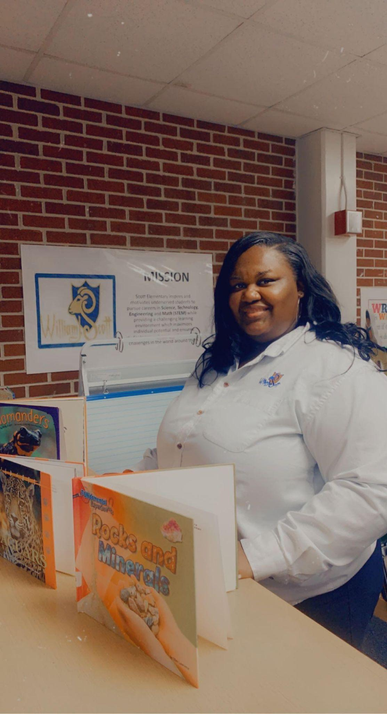

Hi! I am Audrey Rucker, this is my first year serving as a Master Teacher Leader. I was a classroom teacher for 18 years. I taught at Scott Elementary for 15 of those years. I am a graduate of Atlanta Public Schools and Fort Valley State University. I enjoy spending time with family and friends, outdoor concerts, and binge-watching my favorite shows.